1.

addi a1,x0,52 //a1 is the upper border

addi a2,x0,-20 //a2 is the lower border

andi a3,a2,1

bnez a3,cal // a3!=0 jump to cal

addi a2,a2,1 //if a2 is a even number,add 1 to become a odd number

cal:bgt a2,a1,done //determine when the program is done

mul a4,a2,a2 //get the square

mul a4,a4,a2 //get the cube

add s1,s1,a4

addi a2,a2,2 //get the next odd number

jal x0,cal // loop

done:

When the upper border is 52 and lower border is -20.The result is 893376.

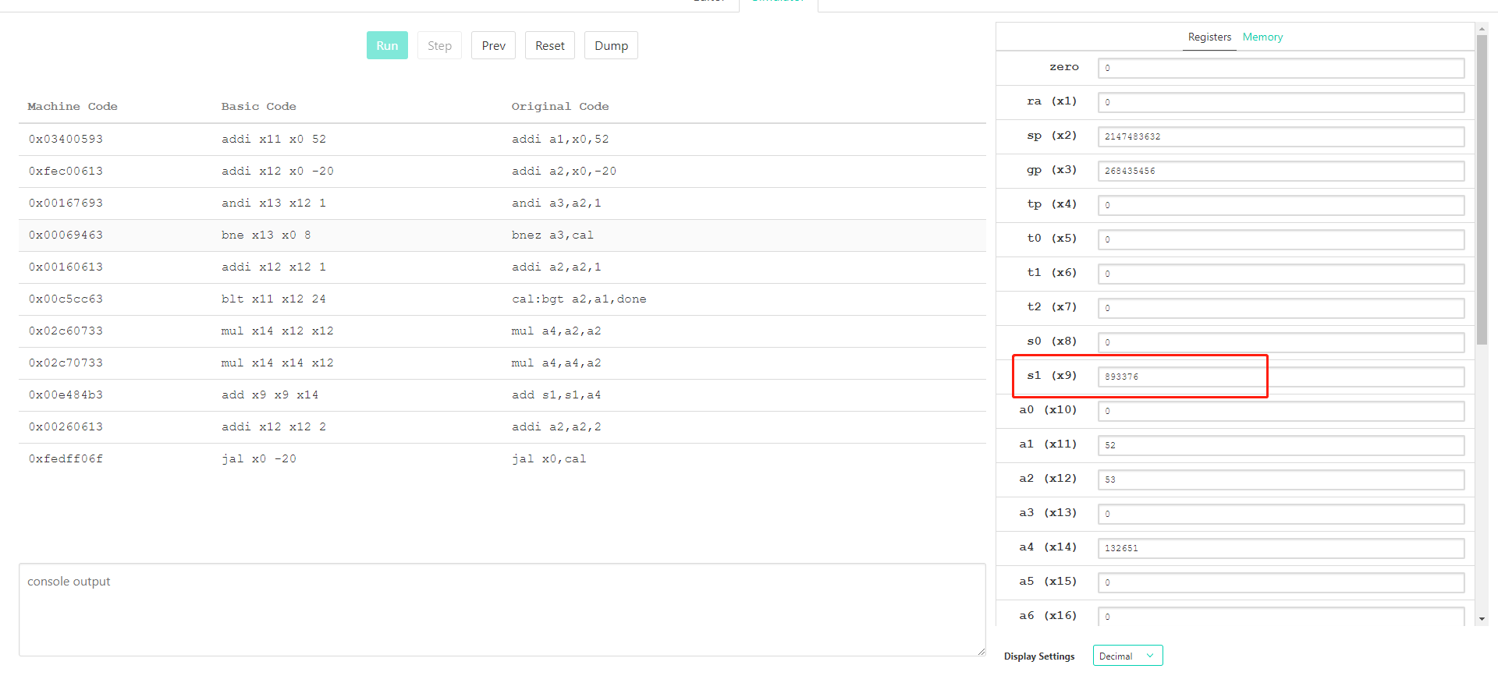

2.

addi a1,x0,10 //a1 is the upper border

addi a2,x0,1 //a2 is the start

addi s1,x0,1 // s1 is the result

loop:bge a2,a1,done // if a2>=a1, the loop is done

addi a2,a2,1 // a2=a2+1

mul s1,s1,a2 //s1=s1\*a2

jal x0,loop // jump to loop

done:

When the upper border is 10, the result 10!=3628800

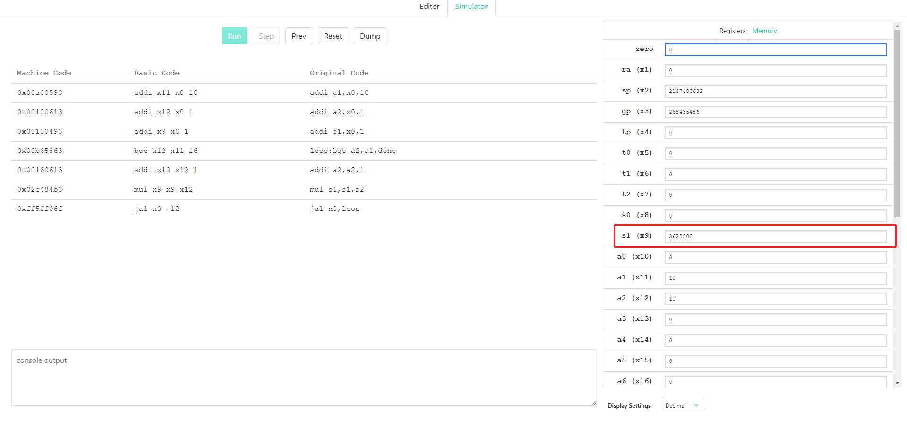

3.

addi a0,x0,11 //a0 is the upper border

addi a1,x0,2 //a1 is the first Prime Number 2

addi s1,s1,2 //s1 is the result

outer: addi a1,a1,1 //a1=a1+1

bgt a1,a0,done //a1>a0 the program is done

addi a2,x0,2 //a2=2

inner:beq a2,a1, cal//a2==a1 jump to cal

rem a3,a1,a2 //a3=a1%a2

beq a3,x0,outer //a3==0 jump to outer

addi a2,a2,1 // a2=a2+1

jal x0,inner // jump to inner

cal: add s1,s1,a1 //s1=s1+a1

jal x0,outer

done:

The upper border is 11. ’outer’ is to traverse form 2 to 11. ‘inner’ is to make sure whether the number is prime or not.The result is 28.

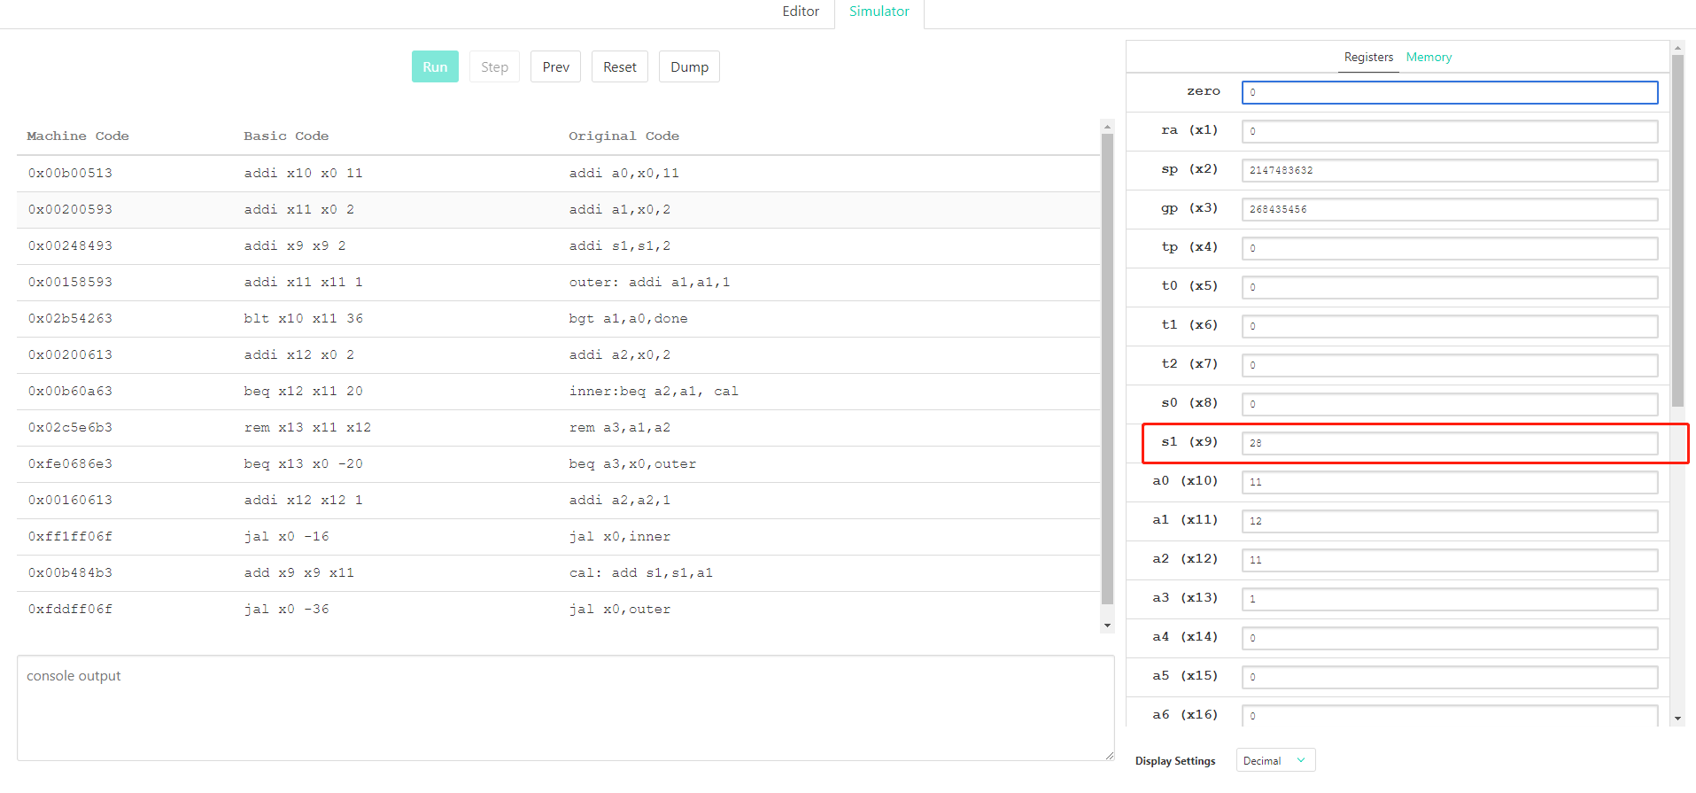

4.

addi a0,x0,4 //a0 is the upper border.N terms.

addi a3,x0,1 //a3=1

addi s1,x0,1 //s1 is the result. s1=1

addi a4,x0,-3//r=-3

addi a1,x0,2 //a1=2

loop:bgt a1,a0,done // a1>a0 the program is done

mul a3,a3,a4 //a3=a3\*(-3)

add s1,s1,a3 //s1=s1+a3

addi a1,a1,1 //a1=a1+1

jal x0,loop //loop

done:

When N=4, the result is -20.

